# Installing Anaconda

1. Go to : <https://www.anaconda.com/>
2. Click green download button in the top right hand corner.
3. Somewhere in the middle of the page you will see :



1. Make your selection
2. Click the green button Accept
3. Important!!! Then make sure to select a “Python 3.7 version” download green button.

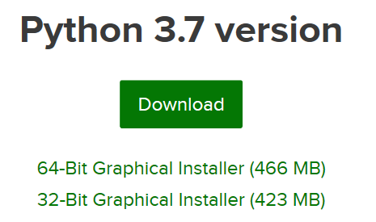

1. If you have a new machine, I would select 64 bit.
2. Then select Run when prompted by windows.
3. Follow all default options

# Running Jupyter

1. Go to your search bar, and type Anaconda, select Anaconda Navigator from apps

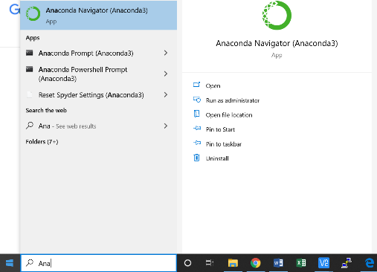

1. This is how you always start Anaconda Navigator:

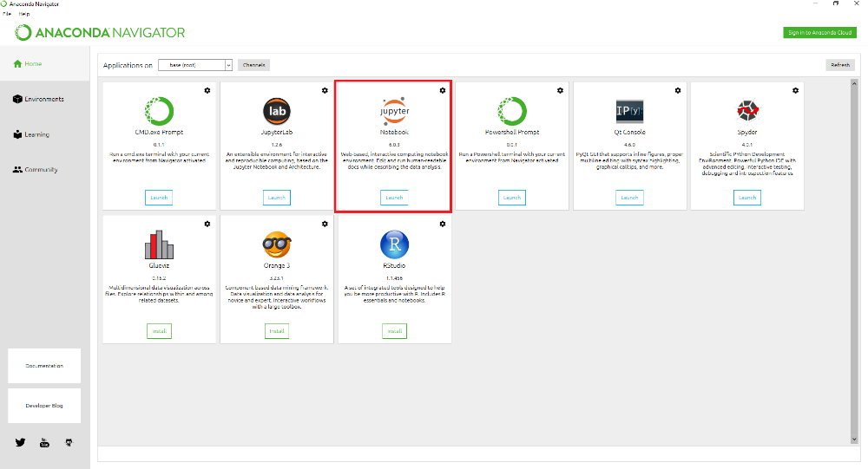

1. Select Jupyter Notebook, select Launch.
2. A browser window should open.
3. Select Documents -> then select Python Scripts
4. On the right you will see a “New” pull down, select Python 3.

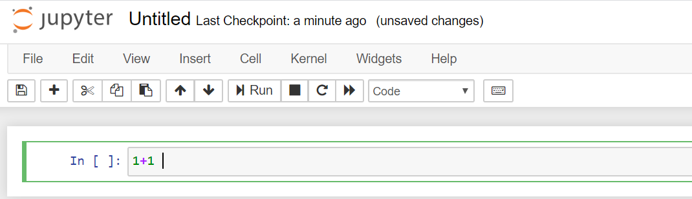

1. Type 1+1, then select “Shift+Enter”, this will execute what is in the cell.

# Installing a Module

1. Python uses modules to abstract programming, and it comes already with almost all of the modules that you would ever need, except this one, that I need for the lesson, to be explained in the lesson.
2. On windows search window type “Anaconda prompt”, and past the following:
   1. conda config --add channels conda-forge
   2. conda install pygithub
      1. Type Y when asked to proceed.
   3. conda install -c anaconda beautifulsoup4
      1. Type Y when asked to proceed.

Here we installed to python packages using the conda prompt. The first package is called pygithuub, and allows for python github access. The second package installed is called beautiful soup, and is used to parse HTML across the web. This package can be used to scrap data from websites when using python for data analytics.

# Downloading the Files

1. Go to the EHSintegration github repo: <https://github.com/ehsintegration/COVID-19>
2. Select the download button to download the Jupyter notbook file. Download as a ZIP file.

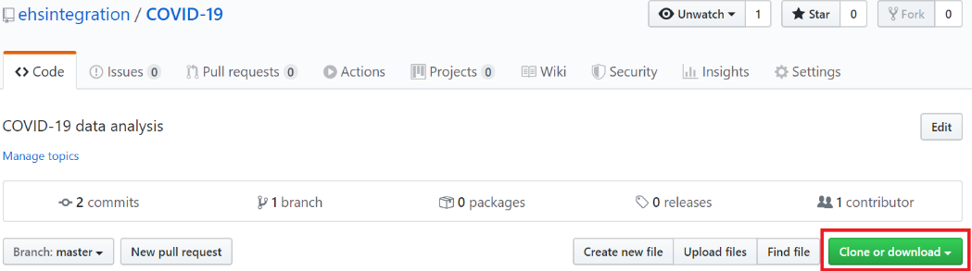

1. Copy the file called COVID-19.ipynb into the Documents\Python Scripts folder.
2. When you start Jupyter as indicated above, you will see the notebook listed. Click to open.

